GATE 1 – FUNCTIONAL REQUIREMENTS ENGINEERING
System Software and Development Tools — Mini Kernel with Process, Memory & File Management
Team 14 | Guide: Ms. Arundati Aralimatti
Sl. No. | SRN | Student Name
1 | 01FE24BCI040 | Pradeep
2 | 01FE24BCI036 | Bhavana
3 | 01FE24BCI055 | Vikitha
4 | 01FE24BCI038 | Zakiya

Section 1: Functional Requirements
FR ID | Description | Priority  (Mandatory/Challenge) | Source Need  (from S0)
01 | Boot and initialize the educational mini-kernel in a controlled emulated environment and make kernel output available. | Mandatory | S0-N2
02 | Create, initialize, track and terminate bounded kernel processes using process identity and lifecycle states. | Mandatory | S0-N2
03 | Allocate and release fixed-size memory pages while maintaining page-availability state.. | Mandatory | S0-N2
04 | Select an eligible process and perform a CPU context transfer between process contexts. | Mandatory | S0-N2
05 | Create, open, read, write, close and remove files using bounded kernel file facilities. | Mandatory | S0-N2
06 | Associate file resources with processes through process identity and file descriptors. | Mandatory | S0-N2
07 | Dispatch supported process, memory and file service requests through the kernel-service interface. | Mandatory | S0-N2
08 | Record selected process, memory, file and service events with information needed to inspect resource-state changes | Mandatory | S0-N3
09 | Measure selected execution/resource operations and make performance evidence available for analysis. | Mandatory | S0-N4
10 | Demonstrate and validate an integrated Process–Memory–File interaction within the kernel. | Mandatory | S0-N5

Section 2: Non Functional Requirements
NFR ID | Description | Category | Measurable Target
01 | Invalid or unsafe page requests shall be rejected without corrupting allocator state. | Reliability | No invalid/double-free test may alter valid allocation state.
02 | The kernel shall execute process, memory and file management operations within specified CPU cycle limits. | Performance | Each supported operation shall complete within its experimentally established CPU cycle threshold under identical QEMU test conditions.
03 | Process, Memory and File responsibilities shall retain clear ownership boundaries. | Modularity | Engines use defined interfaces and do not directly corrupt another engine's internal state.
04 | Validation shall be reproducible in the documented emulated environment. | Reproducibility | Documented build/run/test procedure reproduces the validation sequence.
05 | Observation and performance outputs shall be understandable to learners. | Educational usability | Each demonstration identifies operation, result and relevant state/event/measurement.
06 | The Round Robin scheduler shall ensure fair CPU allocation among ready processes using a fixed time quantum. | Scheduling Fairness | Every continuously ready process shall receive CPU time in cyclic order, with no process being indefinitely starved.

Section 3: Use Casess
ID | Actor | Description / User Story | Main Flow | Exception Flow
UC-01 | Learner / User | Start the mini-kernel in the controlled environment. | Start kernel → initialize required resources → kernel becomes ready → display startup status. | Kernel fails to initialize → display failure information → halt safely.
UC-02 | Learner / User | Create a process for an executable workload. | Submit workload → create process → assign process identity → set initial execution state → process becomes ready. | Invalid workload or process-creation failure → report failure → do not create an invalid process.
UC-03 | Learner / User | Observe and manage the execution state of an active process. | Process enters a state → state changes during execution → current state is maintained → state change is recorded. | Invalid state transition → reject transition → retain valid process state.
UC-04 | Learner / User | Terminate a process and release its associated resources. | Process completes/termination requested → terminate process → release associated resources → record termination. | Termination/resource-release failure → report failure → preserve valid resource state.
UC-05 | Learner / User | Allocate memory for process execution. | Process requests memory → check available memory → allocate required memory → update memory state. | Insufficient memory → allocation fails → report memory-allocation failure without corrupting state.
UC-06 | Learner / User | Release memory associated with a terminated process. | Process terminates → identify allocated memory → release memory → update available-memory state. | Memory release inconsistency → report error → retain resource information for validation.
UC-07 | Learner / User | Perform basic file creation or opening. | Process requests file operation → create/open file → update file state → return operation result. | Invalid/unavailable file operation → return failure → maintain valid file state.
UC-08 | Learner / User | Perform basic file read/write operations. | Process requests read/write → perform operation → update relevant file state → return result. | Invalid operation or unavailable file → report failure → preserve valid file state.
UC-09 | Learner / User | Observe selected kernel events and resource-state changes during execution. | Kernel activity occurs → record selected event → capture relevant resource state → associate event and state → inspect event sequence and available evidence. | Event/state information unavailable or inconsistent → record incomplete observation → identify observation gap → continue without corrupting kernel state.
UC-10 | Learner / User | Measure performance of a controlled workload and repeat it for validation. | Run workload → collect defined performance metrics → record measurements → repeat same workload under same conditions → compare results. | Measurement unavailable, inconsistent, or varies beyond defined conditions → mark measurement invalid → repeat controlled validation run.

Use Case Diagram

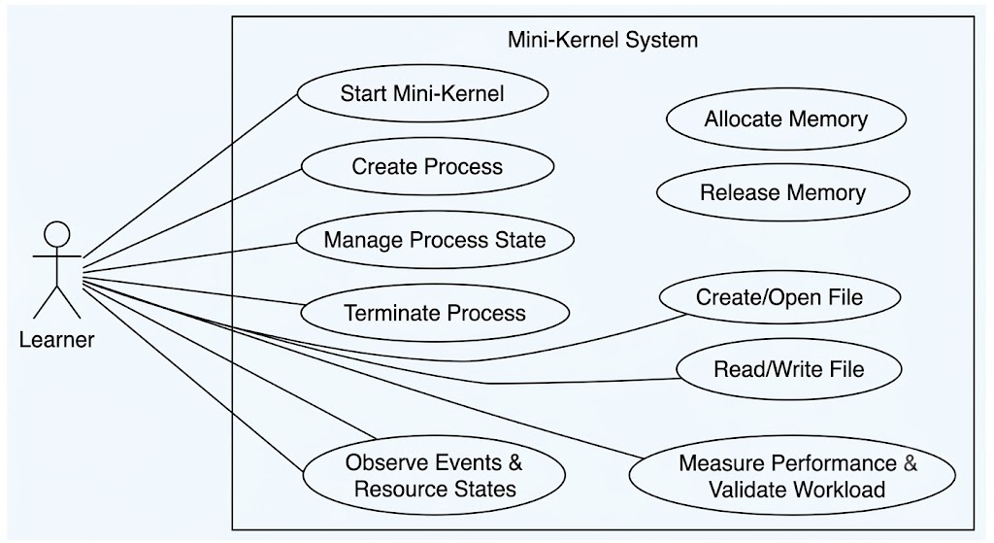

Fig : Use case diagram

Section 4: Acceptance Criteria
Requirement ID | Acceptance Criteria | Test / Verification Method
FR-01 | Kernel starts successfully in the controlled environment and reaches the required startup stage. | Kernel startup test
FR-02 | A process is created with a valid identity and state, and can be terminated correctly. | Process lifecycle test
FR-03 | Memory pages can be allocated and released while maintaining correct memory state. | Memory allocation/release test
FR-04 | A READY process is selected and its context is switched correctly. | Scheduler/context-switch test
FR-05 | Files can be created, opened, read, written, closed and removed correctly. | File operation test
FR-06 | A valid PID/FD identifies the intended file resource. | Process-file integration test
FR-07 | Supported service requests reach the correct subsystem and unsupported requests are rejected. | Service dispatch test
FR-08 | Selected process, memory and file operations generate the required event records. | Event recording test
FR-09 | Selected operations produce measurable performance results using the defined measurement method. | Performance measurement test
FR-10 | At least one Process–Memory–File interaction completes successfully and its result/events can be observed. | Integrated validation test
NFR-01 | Invalid or unsafe memory requests are rejected without changing valid memory state. | Invalid allocation/free test
NFR-02 | When a resource limit is reached, the system reports failure without overwriting valid entries. | Resource exhaustion test
NFR-03 | Recorded events contain the required information consistently. | Event record inspection
NFR-04 | Performance measurements are obtained using the same defined procedure and test conditions, producing comparable cycle-based evidence | Repeated performance measurements
NFR-05 | Process, Memory and File components use their defined responsibilities without directly corrupting another component's state. | Interface/integration test
NFR-06 | The documented build, run and test steps can be repeated in the controlled environment. | Repeat build/run/test
NFR-07 | Demonstrations clearly show the operation, result and relevant event/state/measurement information. | Evidence inspection

